URL: <http://www.sportssurgeryclinic.com/>

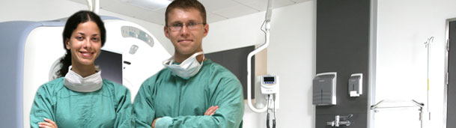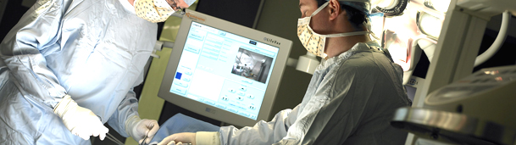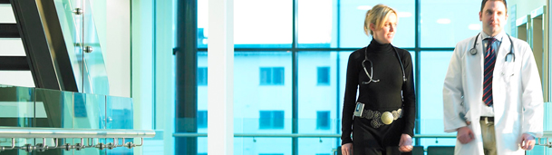

**Our Mission**

The Sports Surgery Clinic’s goal is dedicated to delivering the highest standards of diagnosis, prehabilitation, treatment, rehabilitation and full recovery care for its patients. We aim to provide an exceptional working environment for our staff focusing on continuous education and quality improvement to support excellence in patient care.

**Procedure**

[Orthopaedics](http://www.sportssurgeryclinic.com/departments/orthopaedics.html)

[Knees](http://www.sportssurgeryclinic.com/departments/orthopaedics/knees.html)

[Hands](http://www.sportssurgeryclinic.com/departments/orthopaedics/hands.html)

[Hips](http://www.sportssurgeryclinic.com/departments/orthopaedics/hips.html)

[Shoulder](http://www.sportssurgeryclinic.com/departments/orthopaedics/shoulder.html)

[Foot & Ankle](http://www.sportssurgeryclinic.com/departments/orthopaedics/foot_ankle.html)

[Back & Spine](http://www.sportssurgeryclinic.com/departments/orthopaedics/back_spine.html)

[Sports Medicine](http://www.sportssurgeryclinic.com/departments/sports-medicine.html)

[Specialist Service Provision](http://www.sportssurgeryclinic.com/departments/sports-medicine/specialist-service-provision.html)

[How to make an appointment](http://www.sportssurgeryclinic.com/departments/fitness-testing/how-to-make-an-appointment1.html)

[Cardiology & Respiratory Testing](http://www.sportssurgeryclinic.com/departments/cardiology-andamp-respiratory-testing.html)

[Plastic & Reconstructive Surgery](http://www.sportssurgeryclinic.com/departments/plastic-and-reconstructive-surgery.html)

[Maxillofacial Surgery](http://www.sportssurgeryclinic.com/departments/186.html)

[Diagnostic Imaging](http://www.sportssurgeryclinic.com/departments/diagnostic_imaging.html)

[Diagnostic Procedures](http://www.sportssurgeryclinic.com/departments/diagnostic_imaging/procedures.html)

[Pain Management](http://www.sportssurgeryclinic.com/departments/diagnostic_imaging/pain_management.html)

[Interventional Procedures](http://www.sportssurgeryclinic.com/departments/diagnostic_imaging/interventional_procedures.html)

[Make an Appointment](http://www.sportssurgeryclinic.com/departments/diagnostic_imaging/make-an-appointment.html)

[Referral Forms](http://www.sportssurgeryclinic.com/departments/diagnostic_imaging/di_referral_forms.html)

[Physiotherapy](http://www.sportssurgeryclinic.com/departments/physiotherapy.html)

[Types of Patients](http://www.sportssurgeryclinic.com/departments/physiotherapy/types_of_patients.html)

[Conditions Treated](http://www.sportssurgeryclinic.com/departments/physiotherapy/conditions_treated.html)

[Core Services & Treatments](http://www.sportssurgeryclinic.com/departments/physiotherapy/core_services.html)

[Specialist Services](http://www.sportssurgeryclinic.com/departments/physiotherapy/specialist_services.html)

[Spinal Evaluation Service](http://www.sportssurgeryclinic.com/departments/spinal-evaluation-service1.html)

**Doctor’s credentials**

**Doctors in orthopedic**

 Dr Ray Morgan

Specialising in the management of sports injured knees.

Suite: 5

Phone: +353 1 526 2200

Fax: +353 1 526 2204

 Mr Owen Brady

Specialising in lower limb reconstruction, including arthroplasty, soft tissue and arthroscopic surgery and trauma.

Tel: 01-5262314

Fax: 01-5262317

**Doctor in neurosurgery**

Mr. Michael Kelleher

**Doctor in plastic surgery**

Mr Richard hanson

**Doctor in maxilla facial surgery**

Mr Cliff Beirne

**Doctors in sports medicine**

Dr conor o brien

Dr eanna falvery

**Doctor in anesthesia**

Dr. joseph keaveny

**Contact us**

Sports Surgery Clinic, Santry Demesne

Dublin 9.

Phone us at +353 1 526 2000